
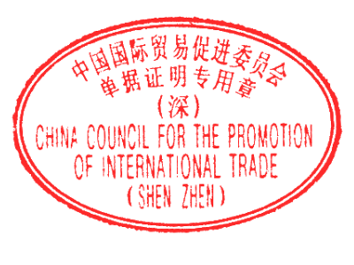
ORIGINAL
Page 1 of 1
.Exporter
1
FLAT C, 10/F., KAI CENTRE, 36 HUNG TO ROAD, KWUN TONG,
KOWLOON, HONG KONG
***
Serial No.
CCPIT7002450104194
Certificate No.
24C700000674/50510
CERTIFICATE OF ORIGIN
OF
THE PEOPLE'S REPUBLIC OF CHINA
2
.Consignee
ST. MUSTAQILLIK 7, KHON-TEPA MSG, KARSHI CITY KASHKADARYA REGION,
UZBEKISTAN REPUBLIC
.Means of transport and route
3
FROM GUANGDONG CHINA TO KASHKADARYA REGION, NISHAN DISTRICT,
NISHAN-AK ALTYN STR., 62, UZBEKISTAN BY TRUCK
5
.For certifying authority use only
VERIFY URL:HTTP://CHECK.ECOCCPIT.NET/
4
.Country / region of destination
UZBEKISTAN
.Marks and numbers
6
7
.Number and kind of packages;description of goods
8
.H.S.Code
9
.Quantity
10
.Number
and date of
invoices
XYLU8008880
TENTS
6306220090
2
SETS
G.WEIGHT
KGS
22287.82
PM-2401
AUG.20,2024
INDUSTRIAL NON-GLARE LED LIGHTS
TOTAL: NINE HUNDRED AND FORTY FIVE (945) PACKAGES ONLY.
9405429000
112
PIECES
G.WEIGHT
256.3
KGS
***
11
.Declaration by the exporter
are
The undersigned hereby declares that the above details and statements
correct, that all the goods were produced in China and that they comply with the
Rules of Origin of the People's Republic of China.

SHENZHEN,CHINA
SEP.30,2024
Place and date,signature and stamp of authorized signatory
12
.Certification
It is hereby certified that the declaration by the exporter is correct.
ADDRESS:4F, BLOCK A, BUILDING OF INTERNATIONAL CHAMBER OF
COMMERCE, 1ST FUHUA ROAD, FUTIAN DISTRICT, SHENZHEN, P.R.C

FAX:86-755-33358500
TEL:86-755-88100008

SHENZHEN,CHINA
SEP.30,2024
Place and date,signature and stamp of certifying authority

